**Lesson 07 Demo 2**

**Accessing Variables in Jinja2**

**Objective:** To access variables in Jinja2

**Prerequisites:** You need to have Python 2.7 or higher, minimum 8 GB RAM, and SSH or SCP communicator.

**Tools Required:** Ansible and Jinja2

**Steps to be followed:**

1. Creating a variable file
2. Configuring a Jinja2 template

**Step 1: Creating a variable file**

* 1. Create your first Jinja2 template by executing the following command:

**sudo nano index.j2**



* 1. Enter the following code in the jinja2 file:

**A message from {{ inventory_hostname }}**

**{{ webserver_message }}**

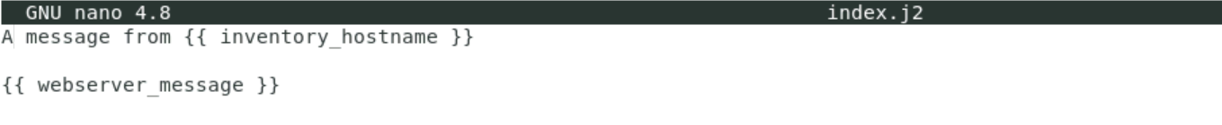

**Step 2: Configuring a Jinja2 template:**

* 1. Create a playbook in which we will install Apache using the jinja2 file:

**sudo nano run-apache2.yml**



* 1. Enter the following code in the playbook:

**---**

**- name: Check if Apache is working**

**hosts: webservers**

**become: true**

**vars:**

**webserver_message: "I am running to the finish line."**

**tasks:**

**- name: Start apache2**

**service:**

**name: apache2**

**state: started**

**- name: Create index.html using Jinja2**

**template:**

**src: index.j2**

**dest: /var/www/html/index.html**

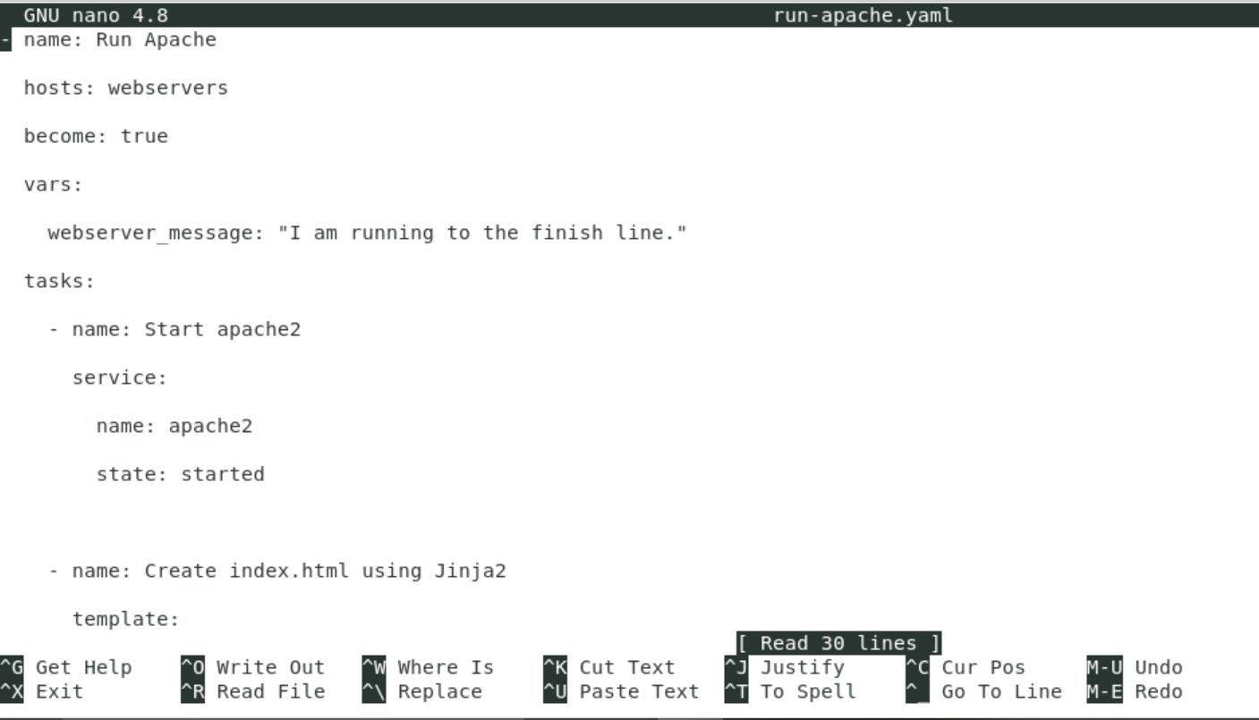

* 1. Run the playbook:

**ansible-playbook run-apache2.yml**

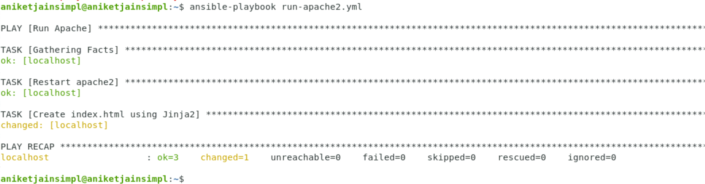

* 1. Run a quick [ad-hoc Ansible command](https://linuxhandbook.com/ansible-ad-hoc/) to check the contents of index.html on the webserver’s nodes:

**ansible webservers -m command -a "cat /var/www/html/index.html"**

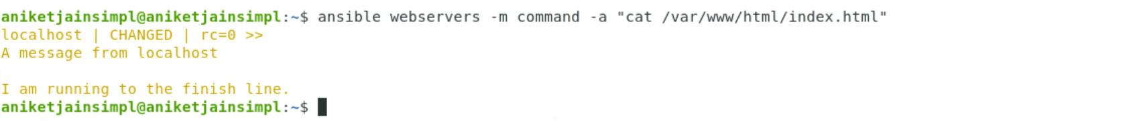

You can notice that Jinja2 is able to pick up the values of the inventory_hostname built-in variable and the webserver_message variable in the playbook.